**Class:** Final Year (Computer Science and Engineering)

**Year:** 2023-24 **Semester:** 1

**Course:** High Performance Computing Lab

**Practical No. 5**

**Exam Seat No: 2020BTECS00023**

**Name: Sumit Narake**

**Title of practical: Implementation of OpenMP programs.**

Implement following Programs using OpenMP with C:

1. Implementation of sum of two lower triangular matrices.
2. Implementation of Matrix-Matrix Multiplication.

**Problem Statement 1: Implementation of sum of two lower triangular matrices.**

**Code:**

#include <stdio.h>

#include <omp.h>

#include <time.h>

#define N 4

int main()

{

    int A[N][N] = {

        {1, 0, 0, 0},

        {2, 3, 0, 0},

        {4, 5, 6, 0},

        {7, 8, 9, 10}};

    int B[N][N] = {

        {11, 0, 0, 0},

        {12, 13, 0, 0},

        {14, 15, 16, 0},

        {17, 18, 19, 20}};

    int result[N][N];

    // Sequential computation of the sum of lower triangular matrices

    clock_t start_seq = clock();

    for (int i = 0; i < N; i++)

    {

        for (int j = 0; j <= i; j++)

        {

            result[i][j] = A[i][j] + B[i][j];

        }

    }

    clock_t end_seq = clock();

    // Print the result matrix

    printf("Sequential Result Matrix:\n");

    for (int i = 0; i < N; i++)

    {

        for (int j = 0; j < N; j++)

        {

            printf("%d ", result[i][j]);

        }

        printf("\n");

    }

    // Calculate sequential execution time

    double seq_time = (double)(end_seq - start_seq) / CLOCKS_PER_SEC;

    printf("Sequential Execution Time: %f seconds\n", seq_time);

    // Parallel computation of the sum of lower triangular matrices

    double start = omp_get_wtime();

#pragma omp parallel for shared(A, B, result) collapse(2)

    for (int i = 0; i < N; i++)

    {

        for (int j = 0; j <= N; j++)

        {

            result[i][j] = A[i][j] + B[i][j];

        }

    }

    double end = omp_get_wtime();

    // Print the result matrix

    printf("Parallel Result Matrix:\n");

    for (int i = 0; i < N; i++)

    {

        for (int j = 0; j < N; j++)

        {

            printf("%d ", result[i][j]);

        }

        printf("\n");

    }

    // Calculate parallel execution time

    double parallel_time = end - start;

    printf("Parallel Execution Time: %f seconds\n", parallel_time);

    return 0;

}

**Output Screenshot:**

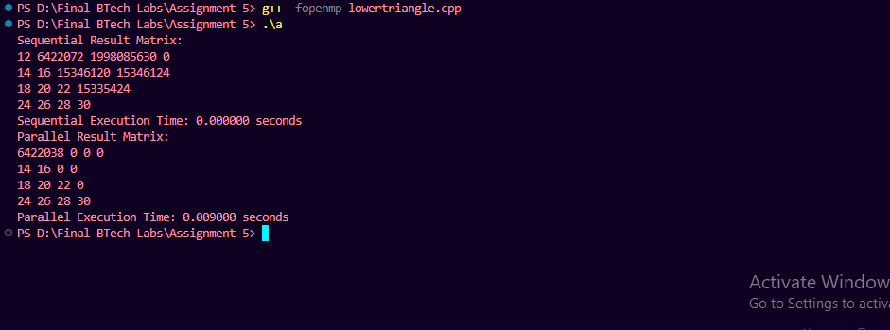

**Information:**

Execution time for sequential and parallel processing is:



**Analysis:**

**With 1 Thread:**

Both the sequential and parallel parts of the code will essentially run sequentially.

The parallel part will have some additional overhead due to thread creation and synchronization.

The parallel execution time will likely be higher than the sequential execution time.

In this case, the program may not benefit significantly from using 100 threads because it's a relatively simple computation. The overhead of thread creation and synchronization may outweigh any potential gains.

**Problem Statement 2: Implementation of Matrix-Matrix Multiplication.**

**Code:**

#include <stdio.h>

#include <omp.h>

#include <time.h>

#define N 3

int main() {

    int A[N][N] = {

        {1, 2, 3},

        {4, 5, 6},

        {7, 8, 9}

    };

    int B[N][N] = {

        {9, 8, 7},

        {6, 5, 4},

        {3, 2, 1}

    };

    int result[N][N];

    // Sequential matrix multiplication

    clock_t start_seq = clock();

    for (int i = 0; i < N; i++) {

        for (int j = 0; j < N; j++) {

            result[i][j] = 0;

            for (int k = 0; k < N; k++) {

                result[i][j] += A[i][k] * B[k][j];

            }

        }

    }

    clock_t end_seq = clock();

    // Print the result matrix

    printf("Sequential Result Matrix:\n");

    for (int i = 0; i < N; i++) {

        for (int j = 0; j < N; j++) {

            printf("%d ", result[i][j]);

        }

        printf("\n");

    }

    // Calculate sequential execution time

    double seq_time = (double)(end_seq - start_seq) / CLOCKS_PER_SEC;

    printf("Sequential Execution Time: %f seconds\n", seq_time);

    // Parallel matrix multiplication

    double start = omp_get_wtime();

    #pragma omp parallel for shared(A, B, result) collapse(2)

    for (int i = 0; i < N; i++) {

        for (int j = 0; j < N; j++) {

            result[i][j] = 0;

            for (int k = 0; k < N; k++) {

                result[i][j] += A[i][k] * B[k][j];

            }

        }

    }

    double end = omp_get_wtime();

    // Print the result matrix

    printf("Parallel Result Matrix:\n");

    for (int i = 0; i < N; i++) {

        for (int j = 0; j < N; j++) {

            printf("%d ", result[i][j]);

        }

        printf("\n");

    }

    // Calculate parallel execution time

    double parallel_time = end - start;

    printf("Parallel Execution Time: %f seconds\n", parallel_time);

    return 0;

}

**Output Screenshot:**

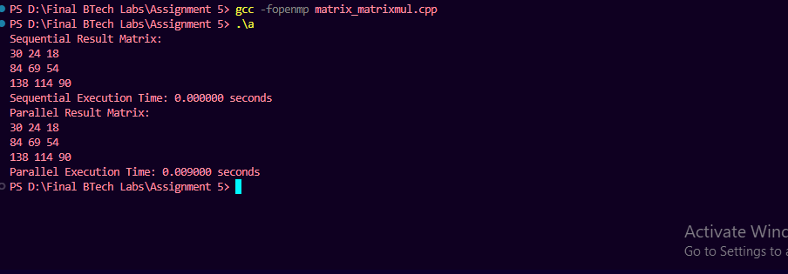

**Information:**

Execution time for sequential and parallel execution is:



**Analysis:**

**Sequential Execution:**

The sequential part of the code computes the result matrix by performing matrix multiplication in a nested loop**.**

**Parallel Execution:**

OpenMP is used to parallelize the loop that computes the result matrix.

omp_set_num_threads(100) sets the number of threads to 100, although the actual number of threads created may differ based on available resources.

#pragma omp parallel for shared(A, B, result) collapse(2) starts a parallel loop that distributes the work among the specified number of threads.

In this case, using 100 threads may not necessarily lead to a significant speedup because matrix multiplication is already a highly parallelizable operation.

**Github Link:**